Jaguar XK Fuse location and ID
There are three fuse boxes:

Engine Compartment
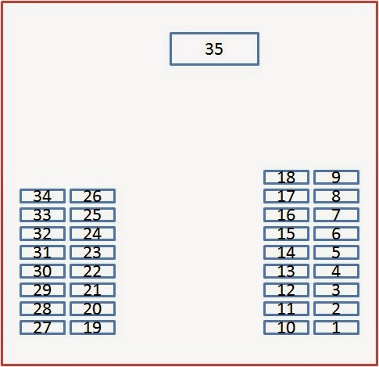

- Not used
- Throttle motor
- DSC ECM; EMS ECM
- Power wash pump
- Not used
- Not used
- Front left screen heater
- Not used
- Cigar lighter heater element
- Horn
- Not used
- Variable valve timing actuators, EMS control module
- Injectors
- EGR valve, Radiator fan control, purge valve, MAF, EVAP monitor, second air injection vacuum solenoid
- ACM/FLS
- Not used
- TCM
- Not used
- Starter
- DSC pump
- Not used
- DSC valves
- Not used
- Intercooler water pump
- Not used
- Wiper motor
- Not used
- Cluster, Front headlight levelling ECM
- Active front lighting (LH)
- Ignition coils and capacitors
- Active front lighting (RH)
- Front right screen heater
- UHEGO - A bank heaters
- UHEGO - B bank heaters
- Radiator fan

Passenger compartment fuse box
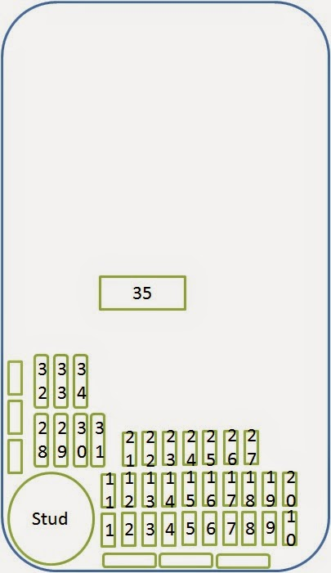

- Not used
- Not used
- Keyless vehicle module
- Not used
- Instrument cluster logic
- Air conditioning
- Passive anti-theft system transmitter/receiver
- Footbrake switch
- Driver's mirror switch, passenger seat memory switch, passenger seat module
- Instrument cluster (column adjust)
- Not used
- Interior lamp switched power comprises - map, courtesy, foot well, sun visor, glovebox, In car aspirator
- Not used
- Adaptive dynamic ride control power
- Not used
- Front power point, premium audio amplifier, cooling fan
- OBD II
- Dual sun load, driver's seat module, driver seat memory
- RF receiver
- Not used
- Not used
- Not used
- Cabin accessory power
- Not used
- Not used
- Not used
- Not used
- Passenger seat motor (2)
- Passenger seat motor (1)
- Driver's seat module (1)
- Not used
- Driver's seat module (2
- Not used
- Not used
- SAI Maxi fuse

Rear Seat compartment
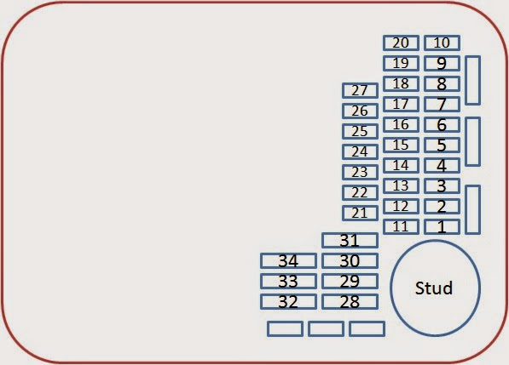
- Passenger door zone ECM
- TPMS
- Not used
- Power rod aerial
- Alternator sense
- Not used
- Not used
- Power roof logic
- Not used
- Accessory connector B+
- Not used
- Not used
- Driver's door zone ECM
- Navigation Power
- Not used
- Not used
- Restraints control module
- EPB
- Active Exhaust
- Not used
- IHU, supply
- Phone power
- Heater rear screen
- Not used
- Sirius Satellite power
- Not used
- Impact sensor
- Not used
- Not used
- Power roof rear quarters
- Power amp supply
- Power roof supply
- Fuel pump module
- Blower motor

