AN INVESTIGATION
AND A PROPOSED SOLUTION TO THE X100 STEERING COLUMN TILT MOTOR INTERMITTENT OPERATION PROBLEM

The intermittent stuttering of the Steering Column Tilt Motor on putting in the ignition key is a feature that has irritated me for the seven years I’ve owned my XK8 and like Bballarin in http://www.jaguarforums.com/forum/xk8-xkr-x100-17/stick-up-down-steering-column-fix-faq-53768/ I’ve recently given a lot of time to thinking and experimenting with possible solutions.

Years ago I went through the well-known routines of lubricating the plastic worm-and-wheel gears, then trying removal and re-tensioning the wave washer. I also disconnected, cleaned and re-made the multiway connectors to the BPM, Door Module, Seat Module and various in-line connectors. None of these actions produced more than a temporary fix to the problem. In fact, it seemed that if the motor/gearbox assembly was removed for any reason, the tilt would operate flawlessly for a while, thus giving the misleading impression that I had got to the bottom of the problem. But always the stutter would return.

Just in passing, all my following work was done with the wave washer correctly installed.

It has been suggested that the problem is the result of an oversensitive over protection device in the Body Processor Module (BPM) supply to the tilt motor. To get around such a protection device I designed and constructed a small relay and diode arrangement that allowed the tilt motor supply from the BPM to be disconnected from the motor and used instead to operate either an Up relay or a Down relay. Those relays then switched an independent 12 volt supply and ground from the front accessory connector directly to the tilt motor. The current to operate the relays was of the order of 20 mA; far less than the near 500 mA drawn by the tilt motor and surely well below any cut-out value.

I was therefore both surprised and disappointed that this new module had no effect at all on the stuttering performance and so had to assume that the problem was not in the 12 volt power supply to the motor.

That left the feedback potentiometer system and I decided to take the same approach of making the system as independent of the BPM as practical.

A study of the JTIS electrical diagrams of the system and the associated information page shows that the system is a variable potential divider. That is, a constant, nominal 5 volt is supplied by the BPM to one end of the potentiometer track, the other end of which is connected back to the BPM to ground. The third wire, connected to the moving wiper contact, can therefore provide to the BPM, a voltage varying between 5 and 0 volts while the tilt moves from Up to Down.
That third wire, the feedback one, is essential to any sort of automatic operation of the tilt system by the BPM, so I left that as a fixed given and addressed only the 5 volt supply and ground.
I started by measuring the actual voltage of the nominal 5 volt supply to the potentiometer while operating the tilt motor manually with the joystick control. With the tilt fully up, the voltage was 4.25, reducing to 4.16 at fully down. It was definite that the motor only stuttered when the voltage was above 4.22.
When bringing the tilt back up, the voltage increased from 4.16 to 4.22 while moving, but when the motor stopped at the fully up position, the voltage continued increasing to 4.25.
Next to be measured was the voltage in the feedback wire. With tilt fully up, voltage was 3.46, fully down, 0.83. Stuttering only occurred above 3.00 v.
In the opposite direction, voltage steadily increased back to 3.00 volts at the tilt fully up position and then, with no further motor movement, it returned to 3.46.
I also did these trials at times when the stuttering did not occur and on those occasions, the voltage variations were virtually the same. From this, it was clear that the stuttering problem was not necessarily caused by higher voltages, but it did only occur at the higher voltages.
So as the stuttering only occurred when the feedback voltage was above 3.00 v, I decided to try replacing the BPM nominal 5 volt supply with an independent one of 3 volts, (though still sharing a common ground system) to eliminate the apparent fault condition and see what the effect would be.
While modifying the wiring to incorporate this 3 v idea, out of curiosity I tried operating the tilt system with the original 5v supply disconnected, but before the 3.0v supply was connected.
The surprising, but promising thing was that the whole system operated faultlessly throughout its full range, with the feedback voltage now varying from only 1.87 v to 0.40, well below the 3.00v threshold for stuttering. Quite why the BPM would supply a voltage to the feedback wire when it was intended to receive a voltage from the now disconnected supply wire, I do not know. Similarly, I was surprised that the tilt system operated through its full design range with such a low level of voltage on the feedback wire. Others may be able to help out here?
However, seeking the simplest solution to make the tilt motor operate properly in all positions, for the moment I shelved the more complex idea of an independent 3 v supply and continued with no power supply to the potentiometer, in effect using it as a variable resistor between the BPM and ground.
Checking that the tilt system behaved correctly in all respects proved that the manual joystick would still move the steering column through its full range while the memory button and the automatic operation on insertion or removal of the ignition key all worked too. Setting new memory positions was also successful and indeed necessary to take account of the new voltage range. The only change to the operating pattern was that on removing the ignition key, the column immediately motored to the high position, but there was then a pause of three seconds before the column reach motor cut in to retract the column fully – acceptable to me as the price for a reliable tilt motor! I hope it doesn’t bite me in the longer term!
For those wishing to give this idea a try or investigate it for themselves, the wire to be disconnected is the White/Blue one between the White 6 way connector on the column and the tilt motor assembly. The Pink wire is the feedback wire and the White/Green one is the ground wire, both of which should be left alone. Although some wiring colours change over the years, these three seem always to have been the same.
I disconnected the wire by removing the motor assembly then removing the black cover held on with one screw and two clips. That gave sufficient access to unsolder the wire from the feedback potentiometer circuit board so it can be easily replaced if required, but it could be cut or maybe removed from the White connector without removing the motor at all.
For those unfamiliar with the layout, this collage of photos shows the process of getting to the motor and opening it up if required. The Blue/White wire and the White connector are arrowed. Access is simply a matter of undoing the two 8 mm bolts at the front lower edge of the trim panel under the steering column and then pulling it rearwards to release the two spring clips at its top front edge. It’s worth unplugging the connectors to the little aspirator fan unit on that panel and the Valet Switch so their wires doesn’t get strained while you work. Just don’t forget to re-connect it on completion!
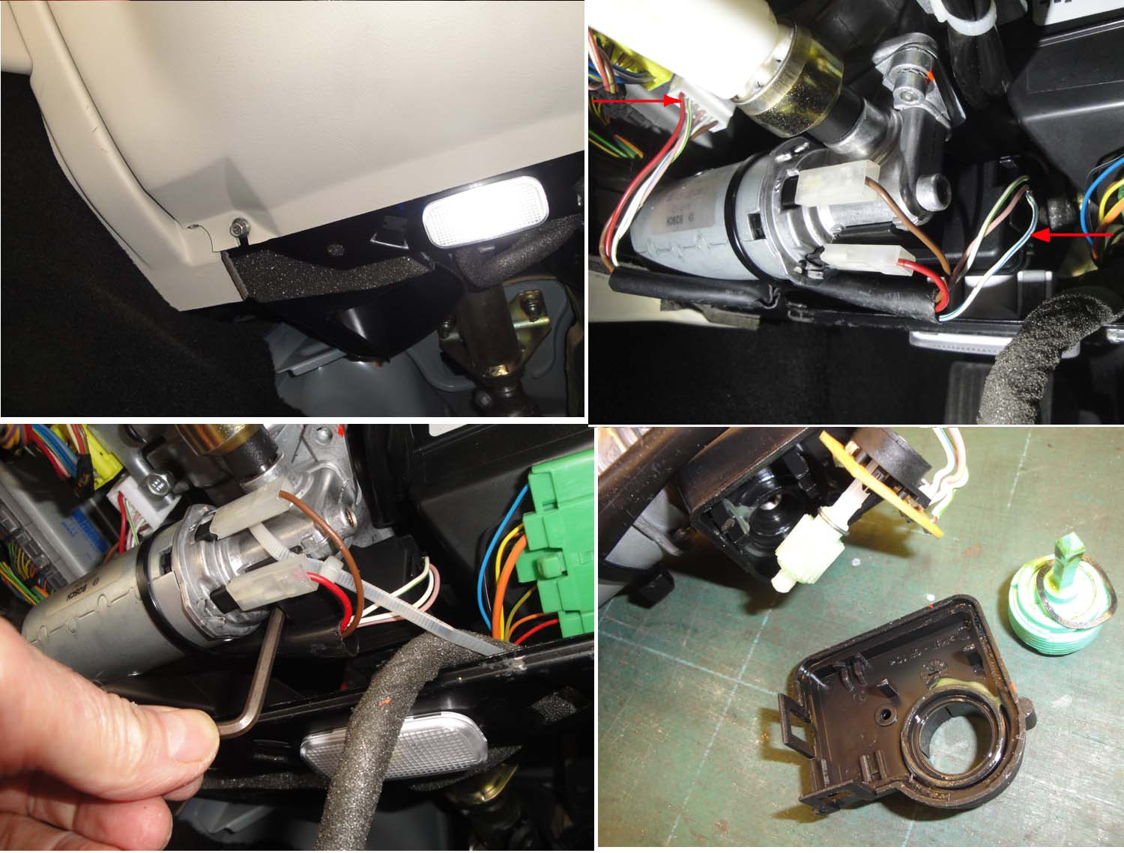
I can’t prove that disconnecting the 5 volt supply to the feedback potentiometer is an absolute solution to the common tilt motor intermittent operation. I can only show that the modified system consistently works for my XK8 and so far has not reverted to intermittent performance that has occurred (mainly!) on and (sometimes!) off for years. Certainly the high voltage condition that originally existed when the motor stuttered has been eliminated. I can say is that the modification has not yet failed within the weeks that have always seen the original system let me down. I’ll keep the Forum updated from time to time.

