Convertible Latch Hydraulic Hose replacement (2001 Jaguar XKR)

Purpose
The purpose of this document is to describe the process I went through to replace the defect hydraulic hoses for the convertible top in my 2001 Jaguar XKR. Since this is a common problem, this document may help other owners to complete the process themselves and save hundreds of dollars on a dealer repair.

Disclaimer
I’m not a mechanic. Use the information in this document at your own risk. While the information provided accurately describes the procedure I used, I can’t be held responsible for missing or inaccurate information.

Remove Back Seat (bottom cushion)
#1 removed passenger side nut from lower rear seat cushion. Used metric 10mm socket.
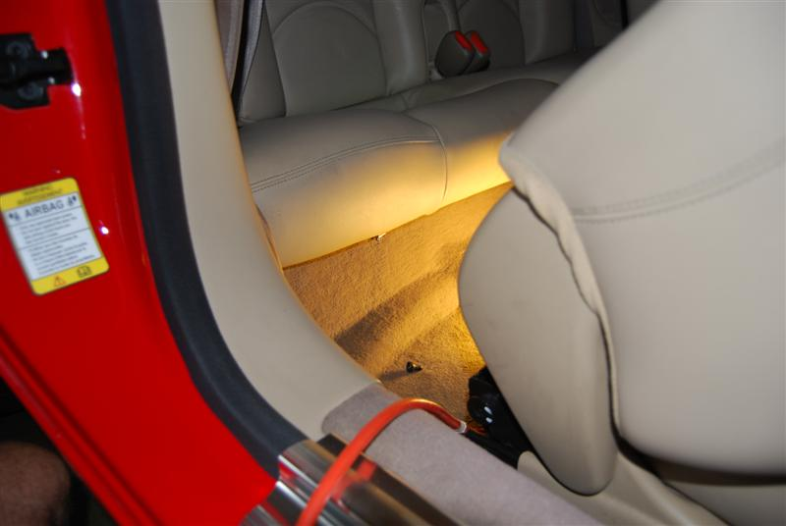
Bolt attached to cushion protrudes down through tab in carpet.
One bolt on each side of seat.

#2 removed driver side nut from lower rear seat cushion. Used adjustable small crescent wrench, socket not deep enough.
Pulled straight up on front of cushion, but it was stuck on center seat belt buckles. Need to unsnap the leather surrounding the buckets and push buckles down through the sleeve.
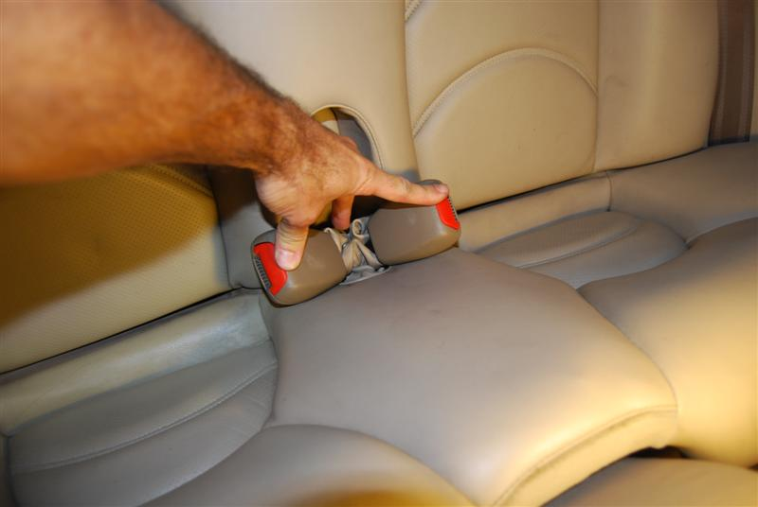
Unsnap the leather covering. This allows latches to be pushed through the hole in the seat.

After the buckle latches are pushed through, pull up on the front of the cushion to remove it.
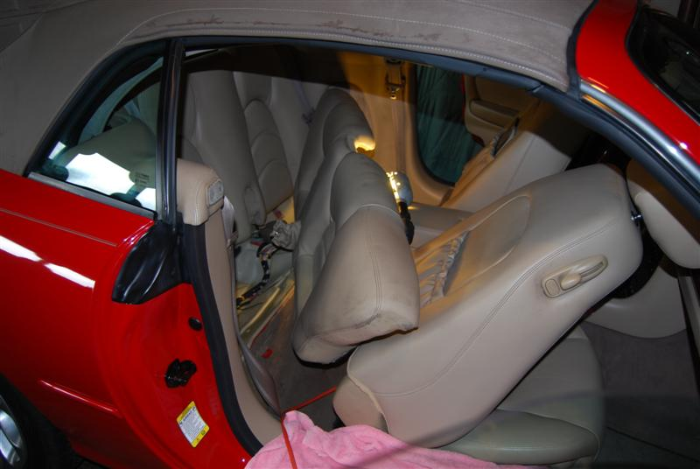

Remove Back Seatback
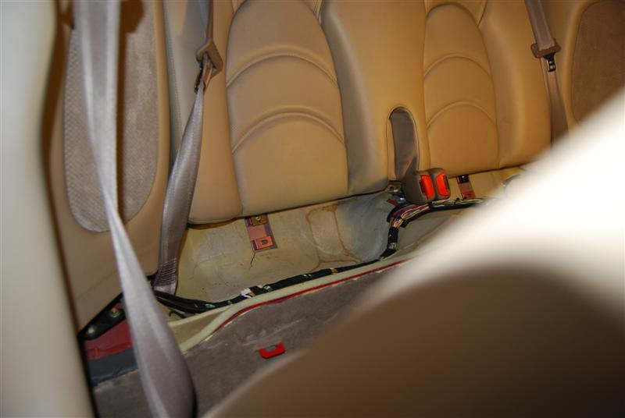
After removing the lower seat cushion, you’ll notice two screws below the seatback cushion, one on each side.

After removing the lower seat cushion, you’ll notice two screws below the seatback cushion, one on each side.
#3 removed screw from bottom of passenger side rear seat back. Phillips screw.
#4 removed screw from bottom of driver side rear seat back. Phillips screw.
Pulled top of rear seat cushion forward. Rear seat belts attached through two plastic guides in top corners of cushion. Need to remove those guides and slide seat belts from them.
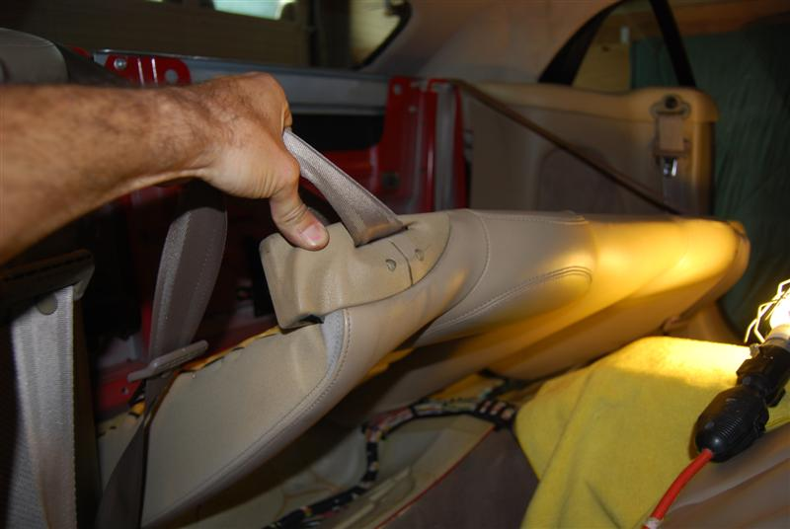
#5, #6 removed 2 phillips screws from passenger side selt belt guide at top corner of rear seat back. Guide stays in the car attached to belt.
#7, #8 removed 2 phillips screws from driver side selt belt guide at top corner of rear seat back. Guide stays in the car attached to belt. Seat back is now free.

Remove Top Cushions above Rear Speakers
#9 removed phillips screw from side on top cushion above passenger side speaker.
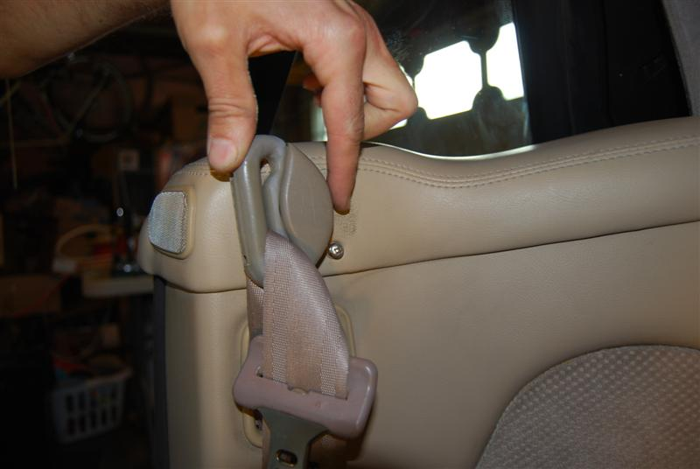
Rotate seat belt guide to reveal Phillips screw on side of top cushion.

#10 removed Phillips screw from top of top cushion above passenger side speaker.
#11 removed post screw from top of top cushion above passenger side speaker. This screw is the post to which the convertible cover latches. It is 2 inches toward the outer side of #10. Hard to remove with the convertible top in closed position. Need 9 mm open end wrench.
#12 removed passenger side belt swivel cover.
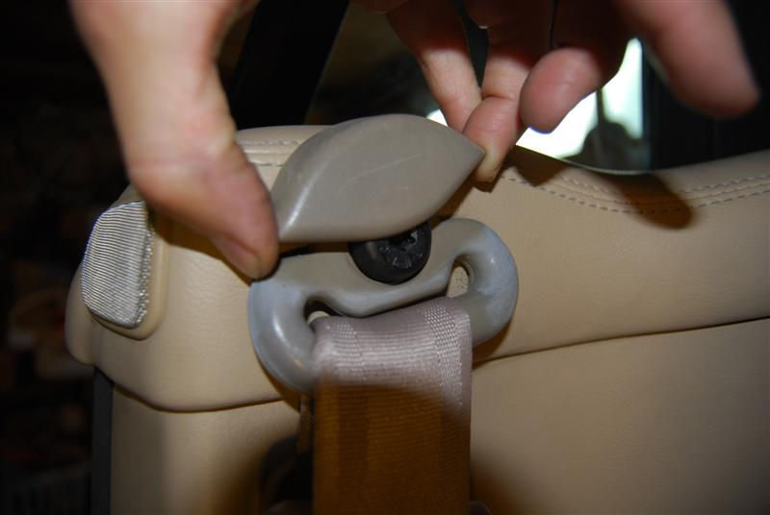
Slide it straight up to reveal torx screw holding swivel in place.
Unscrew torx screw with T50 bit. Assembly stays with belt.
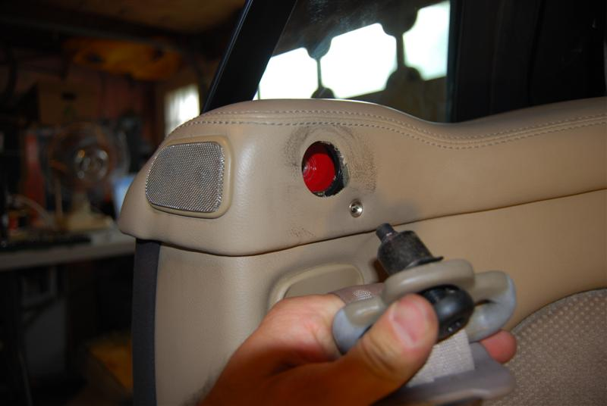
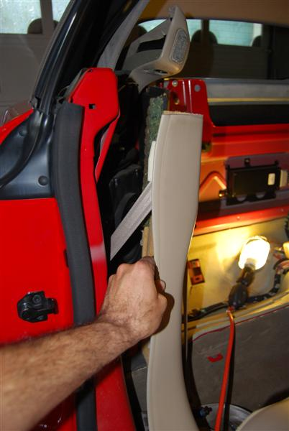
Pop top cushion up. 1 wire holding it in place (for the airbag passenger sensor). Don’t detach yet, just move the cushion up and toward back.

Now pop the speaker cover toward center of car. One tab is under the aluminum door plate. Just pull it a little toward the back of the car to release it. There is a little black plug in the back of the speaker cover. It needs to pop free of the frame, Then the plug should be popped through the speaker cover. The plug hangs on a strip of interior fabric.

#13 Now remove the top cushion by unplugging the white connector. Label #13A and #13B.
At this point, I attempted to drive the car to see if driving with the passenger sensor disconnected is ok. Everything was ok except that the airbag warning light came on in the dash.
#14 Removed big black bar above the speaker. 3 black bolts and 1 silver bolt with washer. 13mm socket.
#15 remove passenger rear speaker. #15A rear torx screw. T30. #15B front torx screw. #15C and #15D are the nuts at the bottom of the speaker. 10mm socket. Label the speaket plug #15E. One unrelated wire goes up the speaker and a little plastic clip attaches it to the side.
#16 remove 1 torx screw from corner of fabric.
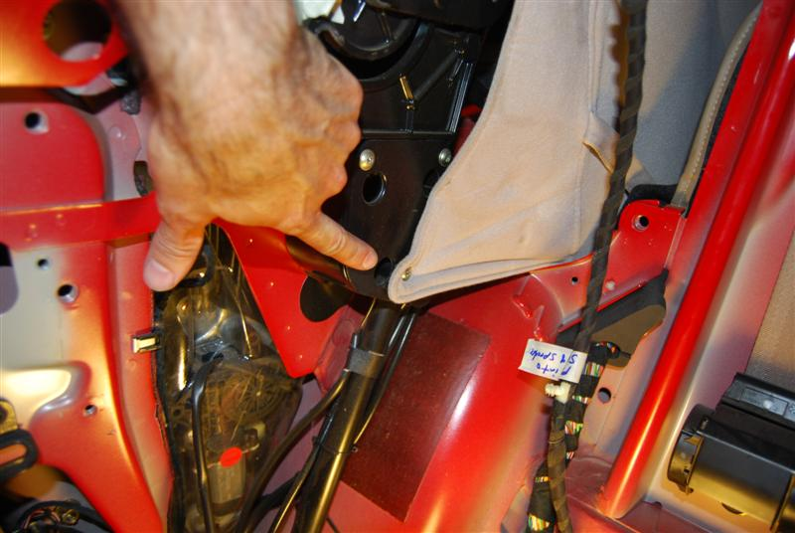
This is passenger-side hydraulic piston that powers the roof up and down.

Remove Driver Side Rear Speaker
#17 remove torx screw holding front seat belt pivot.
#18 remove Phillips screws on top cushion. #18A is long side. #18B is short top. #18C is post screw. #18c is toward outside of car.
#19 remove top driver side cushion above rear speaker by popping it straight up.
#20 removed big black bar on driver side
#21 remove driver side speaker. 2 torx, 2 nuts. #21A, B, C, D
#22 remove torx fabric screw.

If you haven’t already done so, access the pump assembly in the trunk compartment and turn the stopcock a few turns counter-clockwise to put the pump into manual operation mode. This relieves pressure in the hydraulic hoses.
With the back speakers removed, use some tie down straps to pull the hydraulic pistons down into the cylinders a little. This will relieve pressure on the linkage of the roof allowing you to manually lower the roof.

Manually Lower the Convertible Top
Pop out the plug above passenger side sun visor to reveal manual latch socket. Use the hex key provided below the hydraulic pump, insert and rotate about a third of a turn counter clockwise to unlatch the latch.
Carefully push back the convertible top.
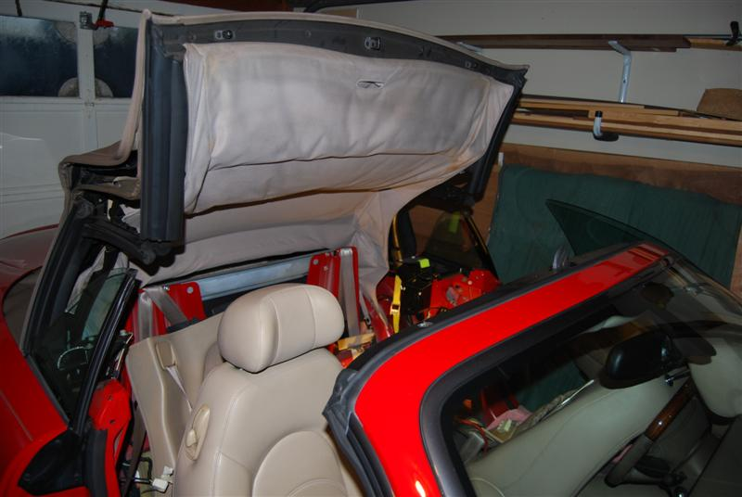
Tie down straps used on each side. Attach at bottom of cylinder and roof linkage just above the top of piston.

Remove the Driver’s Seat
#23 Remove the plastic cover over the front/outside seat rail (next to handbrake). Slide it forward completely.
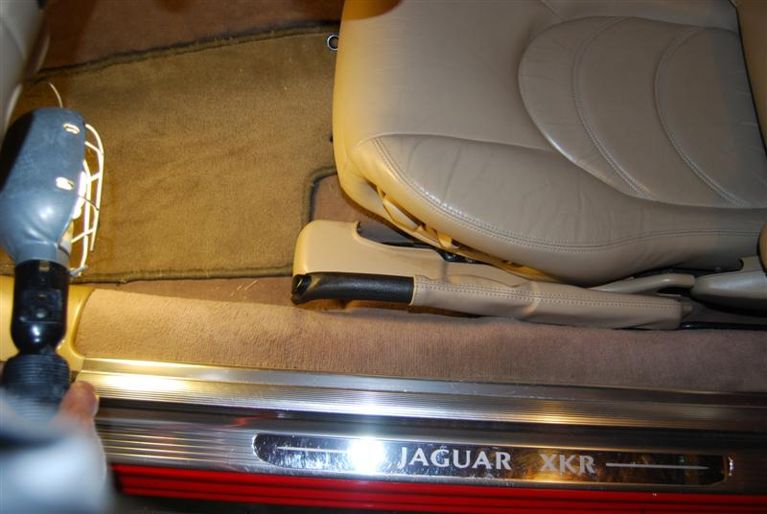
#24 Remove 4 torx screws, T40. Back/outside 2nd hole from the end. Back/inside 3rd hole from the end. Marked with tape.
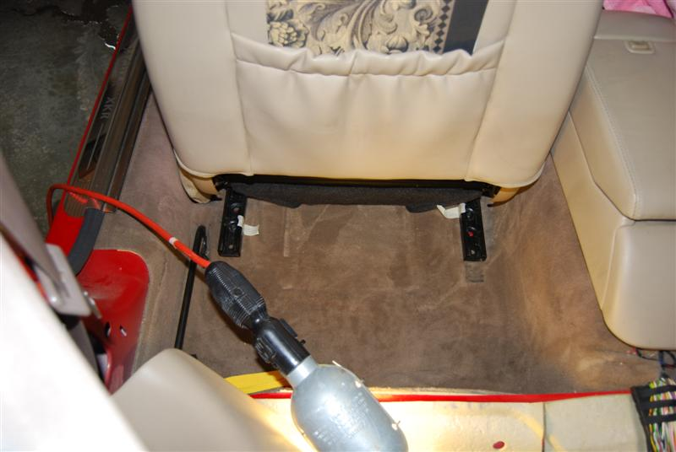
Removed two front screws first, then moved seat to most forward position to access and remove the back two screws.

#25 Disconnect Battery. Unscrew the negative switch/knob #25 (breaks the connection without detaching the battery cable).

Remove the drivers’ seat carefully. I read that you should wait at least one minute after the battery is disconnected before attempting to remove the seat. This lets the side airbag capacitors discharge completely. I folded an old blanket over my door sill to avoid scratching it with the bottom of the seat. It is a bit heavy, so use caution here or get a little help. I tipped the seat to access the power plugs beneath the seat. I disconnected two plugs and one wire clip, then carefully lifted the seat out of the car.

#26 Removed A pillar cover (driver’s side). There are three pressure clips behind the cover. Start at the top with fingers on front and back sides and pull straight out to pop off the cover.

Header parts
#27 Carefully pop off rubber seal plastic clips from corners of header, holding rubber seal down.
#28 Removed 4 screws on top of header. Phillips. Two on corners under rubber seal, two in center on top (black). Note, see #32 below. There are 2 more screws you need to remove from the corners, but they may be hidden a little under the seal.
#29 Removed driver sun visor. 2 phillips screws
#30 Remove screw for driver sun visor latch.
#31 Remove passenger side sun visor
#32 Remove inside liner from top, disconnect all plugs, then notice two more screws protruding from top on corners holding the top face frame on. The two Phillips screws are “hidden” under the rubber goo under the seal. Remove them and you can then remove the top face.
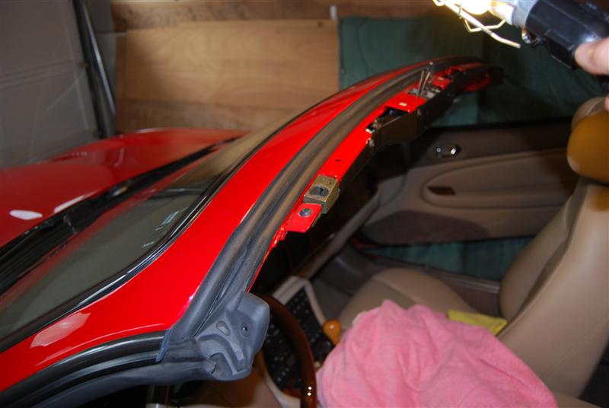
There is a “hidden” screw under the seal goo here. It screws into a tab holding the top plate in place. There is also another screw in the same area that holds the seal to the frame. I removed both screws from each corner.

#33 Removed 10 torx screws from latch frame, loosened a few others and dropped the entire frame onto towels. The longer hose fitting was damaged causing the leak.

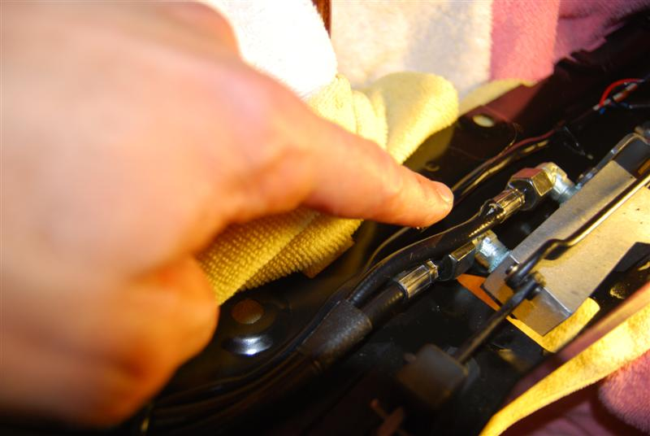
The hose rupture was right here as the hose enters the crimped fitting on the “longer” hose.

I disconnected the old hoses using an open end wrench. I then started removing the old hoses from all their attachments along its path to the left and down the A pillar. I then connected the new hoses to the latch. I wrapped Teflon tape once around the threads of the latch connection before attaching the new hoses. I then tightened the connections with the wrench.
I reattached the header plate to the top of the frame using the 10 torx screws.

Remove Floor Parts
#34 Removed top of left foot rest by pulling straight back toward me. That exposed the bottom portion held in by two screws. Removed with 8mm socket.
#35 Removed flat plastic screw carpet retainer from directly behind brake pedal to loosen carpet.
#36 Removed side kick panel. Quite difficult to remove had to bend it quite a bit.
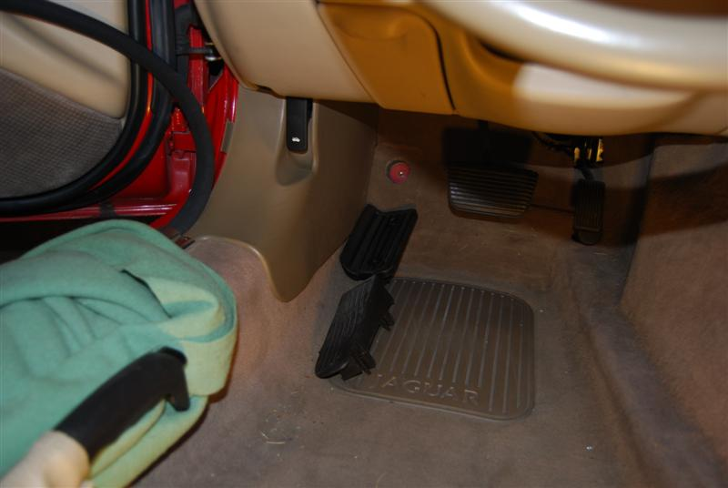
Pull back weatherstripping near the side fuse panel. It helps when trying to access the hoses later.
This kick panel is really difficult to remove. I popped it straight out, but had to twist and contort it to remove it. There MUST be an easier way.
I was surprised to find two foot rests layered on top of each other. The top one pops off, the bottom one has two screws.

BAD IDEA: Don’t do this … I thought I would attach the new hoses to the old hoses with some duct tape to ease “snaking” the new hoses into place. The concept is good and helps get the new hoses down through the bottom of the A pillar through the dash, however, make sure you get the hydraulic fluid out of the old hoses first. The fluid “melted” the duct tape into a gooey mess, wasting a lot of my time. So I would recommend this first:
- Unhook enough of the old hoses to allow them to hang freely to the ground beside your car.
- Put the ends of the hoses into a collection container (I used an old jar).
- Go to the trunk and unfasten the hoses from the pump.
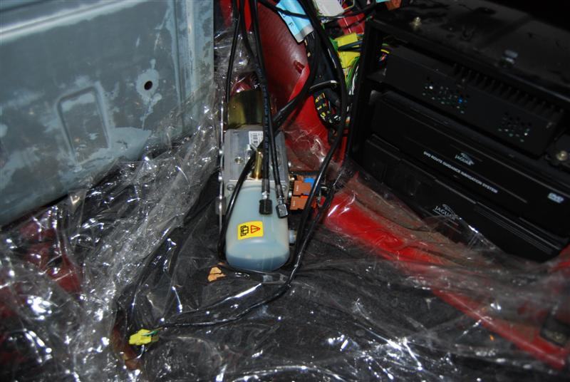
Used old shower curtain to contain fluid.

Old hoses disconnected from the pump.
- Blow compressed air (use low pressure to avoid spraying the old fluid all over your garage).
- As you blow the air through each one, put a mark on the pump fitting to indicate which hose is which. You’ll need to know this later when you hook up the new hoses. I marked the “longer” damaged hose with an “F” on the pump fitting. This is because the new hoses have an “F” on the “longer” hose on both ends.
Now that the old hoses are free of fluid, you can attach the old hoses to the new hoses to help the “snaking” process. At this point however, I didn’t have to snake the new hoses.
I proceeded along carefully around the fuse panel next to the driver door. To get the old hoses out of the white clip, I fashioned a piece of stiff, flexible wire (like a clothes hanger wire) into a loop. Then fished it around the old cable to a point where I could pull the wire and pop the hoses out of the clip. This was the most difficult part of the replacement. It also helped to pull back the weather stripping next to the fuse panel from around the door opening, as this gives you a little more access to the hoses.

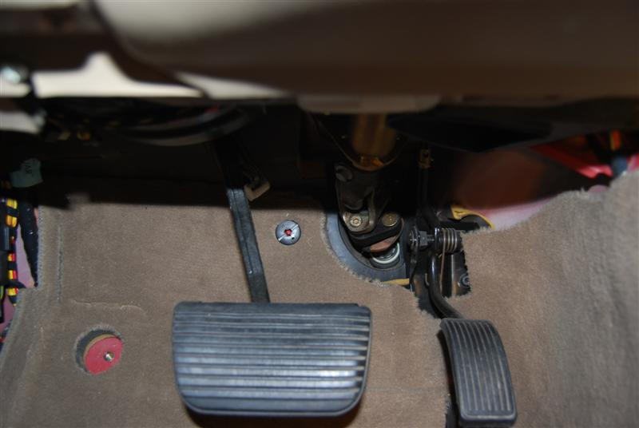
This flat-head screw should be removed. This allows the carpet to be completely rolled back.

I didn’t need to remove the center console for this process, as did others. When pulling back the carpet, I started behind the brake and accelerator pedals, then pulled the carpet out from under the center console. It was stuck a little under the console, but a firm pull dislodged it completely. I was then able to fold the carpet back from the floor completely exposing the hydraulic hoses.

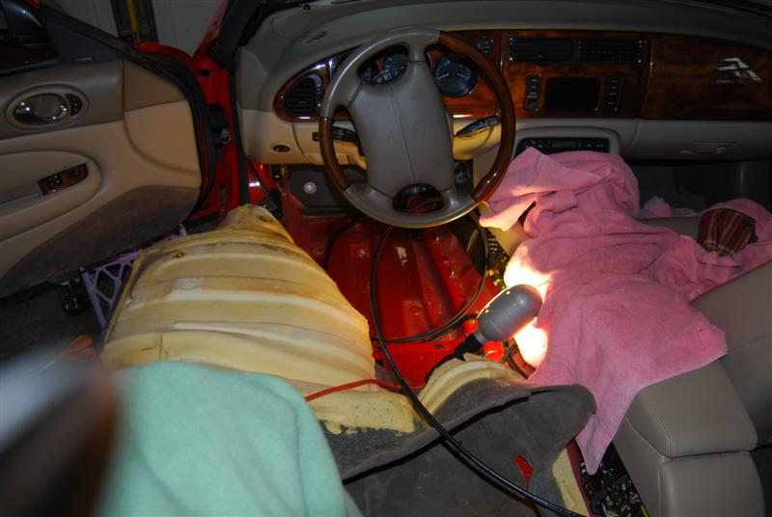
Un-tuck carpet from under the center and rear console.
Hoses run next to the console, then cross over to the passenger side right behind the rear console.

Carpet rolled back toward driver door to expose hoses.

I rolled back the carpet to expose the hoses. I cut the old hoses as I went along to make them easier to remove. MAKE SURE YOU DON’T CUT YOUR NEW HOSES BY MISTAKE; that could ruin your day!
I pulled the old hoses out of the white plastic clips and put the new hoses back into the clips as I went along. I also used a lot of new plastic cable ties to keep the hoses in place.
You will work the new hose back near the passenger-side rear speaker area and then up above the wheel fender area. As you look toward the back of the car from the speaker area, you will see a large bundle of wires running into the trunk through a small hole. I chose NOT to remove the old hose from that bundle. Instead, I cut it to a convenient length and used cable ties to secure it to the frame. I then fished the new hoses through the small hole into the trunk. I used cable ties to secure it to the existing wire bundle.
With the new hoses in the trunk, I connected the hose labeled “F” to the fitting on the pump I had marked when I blew out the old hoses. I then connected the other hose to the other fitting. I then put the pump back on top of the dvd box (without securing it yet).
I reassembled all the loose panels, the sunvisors, the carpet, re-installed the driver’s seat, etc.
Now it’s time to try the top. I reconnected the battery. I turned the stopcock on the pump from the manual to automatic position. I then put the keys in the ignition and tried the top. It made some awful sounds at first. I assume this is because the new lines had to be purged of air and replaced with fluid. After a few up/down cycles, I checked the fluid in the pump. It was low, so I took the pump down to the bottom of the trunk, opened the fill valve and added more fluid to the bottom mark. I put it back on the dvd box and tried a few more up/down cycles. I did this a few times until I got the fluid level just right. Eventually the noise levels went back to normal.
I also took this opportunity to smooth out the wrinkles in the fabric covering the A-pillars. I brought them to a fabric store to get their advice. I ended up using a fabric glue “E-6000”. I cleaned the edges of the fabric on the backside, cleaned the edges of the pillar cover itself, then re-glued the edges of the fabric to the back while stretching it firmly. Let it dry overnight and installed it in the morning. Looks MUCH better now.
The convertible top is working great now. It was a long process for me, but saving $1500 was worth it. I also enjoyed learning more about my car in the process.
Good luck to everyone else who attempts this process. Keep posting new tips and tricks to make it easier for the next guys!
Steve

